1.Design a DFA for the following languages

1.1 Binary strings having odd no of 1’s and any number of 0’s

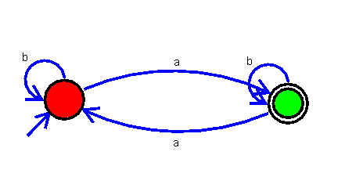

1.2 Binary strings having even no of 0’s and even no of 1’s

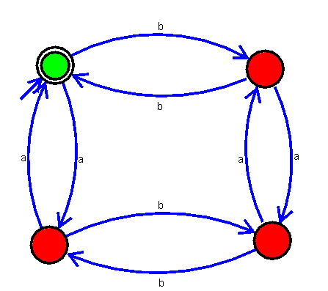

iii) Binary strings having the substring 101

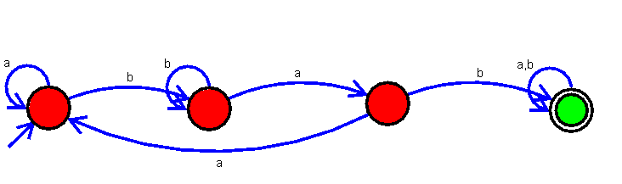

iv) Binary strings having no consecutive 0’s

